Nine lies about work
From work-life balance to feedback and from well-rounded employees to leadership, best-selling author Marcus Buckingham and Cisco leadership and team intelligence head Ashley Goodall argue that many of the accepted truths of work are deeply flawed in their provocative new book
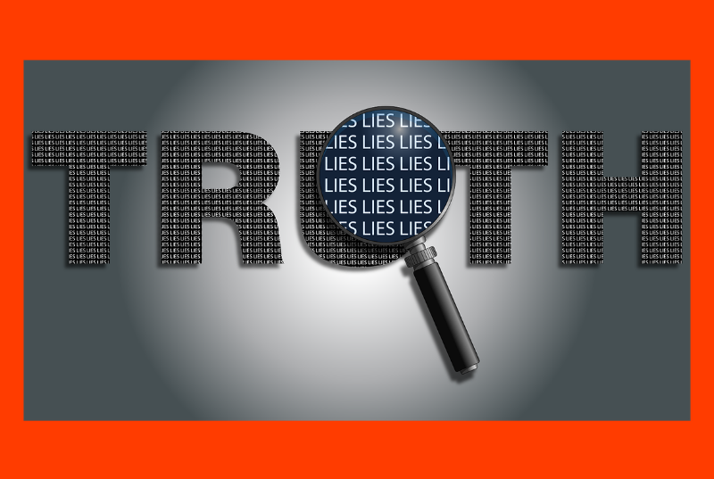
Do you believe people care which company they work for? Are you convinced that your people need feedback? Do you think all people have potential? If so, you have fallen for the accepted truths of work; truths that have grown to become commonplace as a result of organisations’ need for control, simplicity and order but which are, in fact, lies.
In their book Nine Lies About Work: A Freethinking Leader’s Guide to the Real World, authors Marcus Buckingham and Ashley Goodall expose the disconnect between the ways you know you work best and the ways you are told to work. They examine the practices that organisations do to exert control and impose uniformity: practices that have become common wisdom but that have failed to result in improved productivity and employee motivation.
Their nine lies:
- People care which company they work for
Yes, this seems odd, as generally people do feel some connection to their company. But, say the authors, while what we may care about starts as the ‘company’ it soon becomes something else. Local experiences – how we interact with immediate colleagues – trumps company and uniform ‘culture’ every time. When people choose not to work somewhere, that somewhere is not the company but the team. Data shows people might care which company they join but they don’t care which company they work for. They care which team they are on.
- The best plan wins
When you join a company in a leadership role, the first thing you are expected to do is create a plan. Most likely, you’ll be asked what your 90-day plan is. If you can just get the plan right and weave it into the company plan, then we would know resources were allocated appropriately, the correct timing and sequence was laid out, each person’s role was clearly defined and we have enough of the right people to fill the roles. Success will follow. Yet things rarely turn out the way you hope they will. In the real world, change happens fast. The reality is that most plans, especially those created in large organisations, are overly generalised, quickly obsolete and frustrating to those asked to execute them. It’s better to coordinate your team’s efforts in real time, relying on the informed, detailed intelligence of each unique team member.
- The best companies cascade goals
Goals are everywhere at work. Team members look at their leaders’ goals, leaders look at the company goals, everyone has a set of goals designed to help advance the overall goals. SMART, KPIs, BHAG (Big Hairy Audacious Goals), massive amounts of time and money are invested in goal setting. Buckingham and Goodall point out that Deloitte spends $450 million a year on setting, tracking and evaluating every year and Accenture spends double this. Goals are about stimulating the performance of your people in the right direction. The problem is, in the real world there is stuff to be done. Work is work, goals are not. But goals can be good, they just need to be set voluntarily. “Your goals define the dent you want to make in the world.” The best companies don’t cascade goals, they cascade meaning.
- The best people are well-rounded
The one condition that stands out time and again when you analyse the data is the employee’s sense that they have the chance to use their strengths every day at work. “Ongoing work strengths is the master lever for high-performance teams. Pull it and everything else is elevated; fail to pull it and everything else is diminished.” So why do organisations fail to help people pinpoint and contribute their unique strengths? Instead, they measure us against a standardised model and try to get us to become as similar to this model as possible. They think the best people are well-rounded. In the real world, each high performer is unique and distinct and excels because that person has understood his or her uniqueness and cultivated it intelligently.
- People need feedback
“It is a truth universally acknowledged that a millennial in possession of a job must be in want of feedback.” Feedback is a good thing and the more frequent and candid it is, the better. Wrong. The truth is that people need attention and when you give it to them in a safe and non-judgemental environment, they stay and play and work. Yes, feedback is attention, and research shows even negative feedback has some positive impact over no feedback. But negative feedback doesn’t enable learning, in fact it inhibits it. Positive attention, meanwhile, is 30x more powerful than negative attention in creating high performance. Pay attention to what’s working for your people now and build on it.
- People can reliably rate other people
Talent reviews. Performance ratings. The dreaded PIP (performance improvement plan). We all know that managers and their teams hate them. In the real world, none of the methods nor meetings, competencies and carefully calibrated rating scales work. And this is because all of them are based on the belief that people can reliably rate other people. They can’t, as copious research shows. Everyone displays their own rating pattern. The rating you get tells you more about the rating pattern of your manager than about your performance.
- People have potential
As a leader you will inevitably have to rate your people on their potential and put them in a grid somewhere. Are they high or low potential? Then you will allocate their development and investment based on where they sit in that grid. But, “high potential is the corporate equivalent of Willy Wonka’s Golden Ticket: you take it with you wherever you go and it grants you powers and access denied to the rest of us.” The problem is potential is not a trait, it is not inherent in people. Plus, we have already seen that people cannot reliably rate other people. Evidence shows that the ability to learn exists in all of us, it shows up differently in each of us and none of us will ever be able to rewire our brains to excel at everything. To say you have potential simply means you have the capacity to learn, grow and get better like every other human being. It’s not about whether people can grow. It’s about helping team leaders about human growth and promoting them to discuss careers with tier people in terms of ‘momentum’– who each team member is and how fast each is moving through the world.
- Work-life balance matters most
If there’s a phrase that has been used in HR more than most in recent years it’s work-life balance. We lose ourselves in work and rediscover ourselves in life. We survive work and live life. “The answer to the problem of work is to balance it with life.” The assumption is that work is bad and life is good. The problem is balance. In the real world, does anyone find balance? Striving for it can be as hard as the work we are blaming. Balance is just a coping strategy. Love-in-work is what you should strive for. This is not finding work you love, it is the skill of finding love in what you do. What we really wrestle with is not work and life but love and loathe.
- Leadership is a thing
Leadership does not live in the abstract, it lives in the real world. And it is scarce. If leading were easy, there would be more good leaders. There is not a particular set of qualities that leaders have. Every leader has obvious shortcomings. When you take away the definitions of leadership as a thing and look at people you regard as leaders in the real world, you find exception after exception. The only determinant of whether anyone is leading is whether anyone is following. So the question is, why do we follow? “Leadership isn’t a thing, because it cannot be measured reliably. Followership is a thing, because it can.” To conclude, the currency of leadership and followership is human interaction and relationships.

Nine Lies About Work: A Freethinking Leader’s Guide to the Real World by Marcus Buckingham and Ashley Goodall is available now and published by Harvard Business Review Press
